TC-PM-016
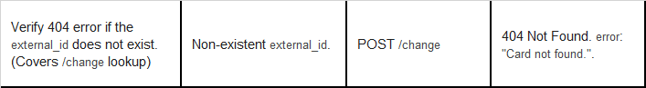
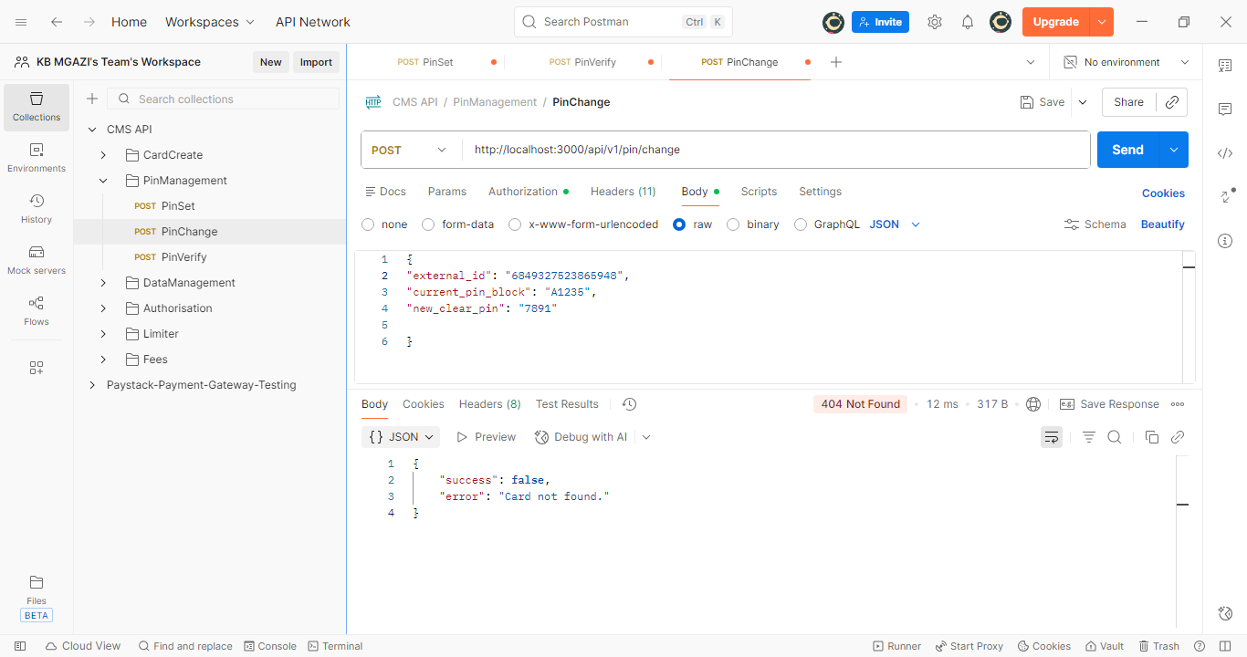
Request:
{
"external_id": "6849327523865948",
"current_pin_block": "A1235",
"new_clear_pin": "7891"

}
Response:
{
"success": false,
"error": "Card not found."
}

